**REPORT ON UNLOCKING INSIGHTS INTO THE GLOBAL AIR TRANSPORTATION NETWORK WITH TABLEAU**

# INTRODUCTION:

This Global Air Transportation Network dataset is a comprehensive collection of information on airports, airlines and their routes. It contains information such as name, cities, countries, codes (IATA and ICAO) longitudes, latitudes and altitudes of airports across the world with detailed time zone and daylight saving time data. Additionally, this includes information about airlines including their IDs, name aliases, IATA and ICAO codes, callsigns country of origin and active /inactive status. Similarly, it also covers routes details such as airlines sources to destination airports along with essential details like codeshare stakeholder if any stops required during this journey along with the type of aircraft being used for that particular journey. This dataset has been complied through meticulous labor by researchers all over the world to give you a comprehensive details into air transportation networks from around the globe. It requires your generous donations in order for them to keep updating this data source so please do donate if possible.

* 1. **CHARACTERISTICS OF AIRPORTS:**

1. One system of transportation which tries to improve the accessibility to inaccessible areas.
2. Provides continuous connectivity over water and land.
3. Provide relief during emergencies and better compared to other sometimes.
4. Saves productive time, spent in journey.
5. Increases the demand of specialized skill work force.

* Unbroken journey
* Rapidity
* Expensive
* Special preparation

1.2 CLASSIFICATION OF AIRPORTS:

* Based on take off & landing
* Based on geometric design
* Based on function
* ICAO (International Aviation Authority Organization)

Classification

Based on the length of runway

Based on using span & outer main gear wheel span

* FAA (Federation Aviation Administration) classification

Aerodomes in india

1.3. TYPES OF AIRPORTS BASED ON FUNCTION:

There are three types of Airports

* International Airports
* Domestic Airports
* Regional Airports

1.3.1 INTERNATION AIRPORTS:

An international airport has direct services to many other airports. Handle scheduled commercial airlines both for passenger and cargo. Many international airports also serve as “HUBS”, or places where non-direct flights may land and passengers switch planes. Typically equipped with customs and immigration facilities to handle international flights to and from other countries.

1.3.2 DOMESTIC AIRPORTS:

A domestic airport is an airport which handles only domestic flights or flights within the same country. Domestic airports don’t have customs and immigration facilities and are therefore incapable of handing flights to or from a foreign airport. These airports normally have short runways which are sufficient to handle short/medium haul aircraft.

1.3.3 REGIONAL AIRPORTS:

A regional airport is an airport serving traffic within a relatively small or lightly populated geographical area. A regional airport usually does not have customs and immigration facilities to process traffic between countries. Aircraft using these airports tend to be small business jets or private aircraft (general aviation).

1. PROBLEM DEFINITION & DESIGN THINKING:

In this problem definition and design thinking we will see the ideation and thought of this topic through empathy map and brainstorming map.

2.1 EMPATHY MAP:

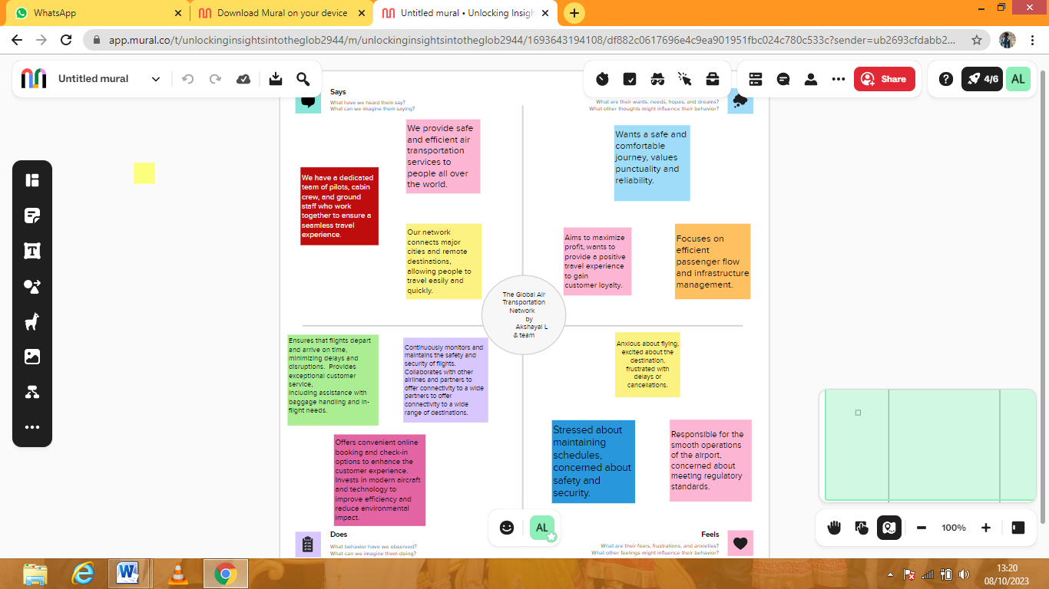

**2.2. Brainstorm Map:**

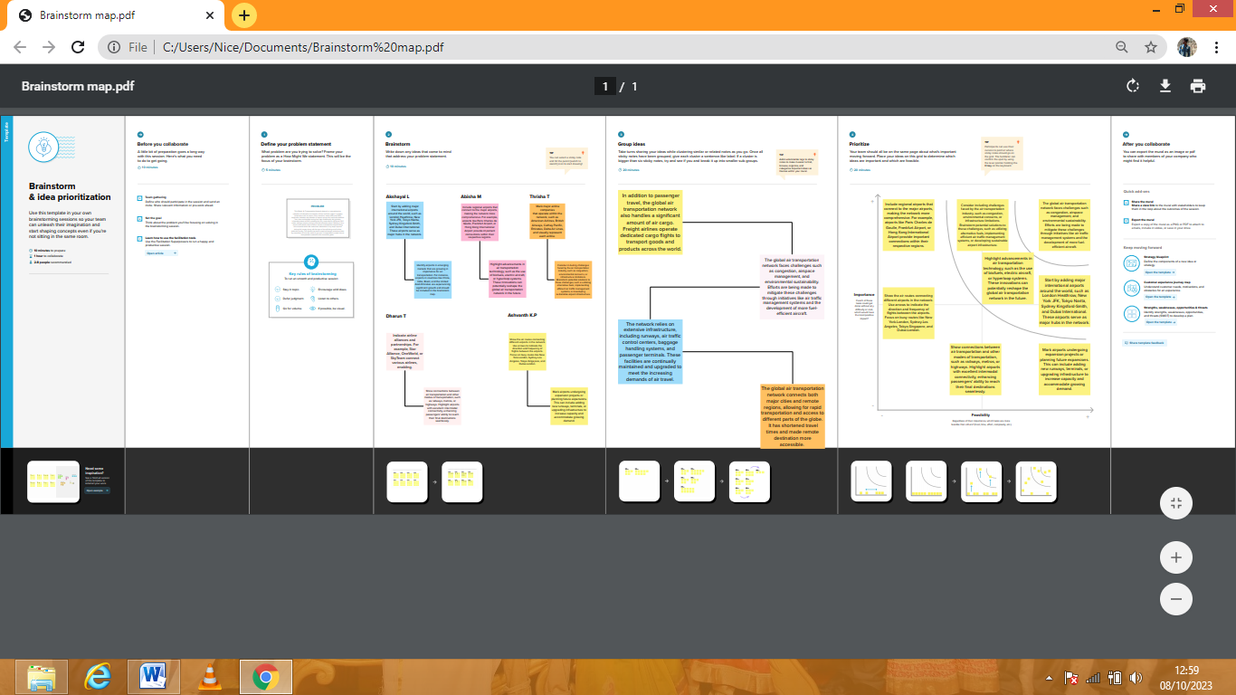

1. **RESULT:**

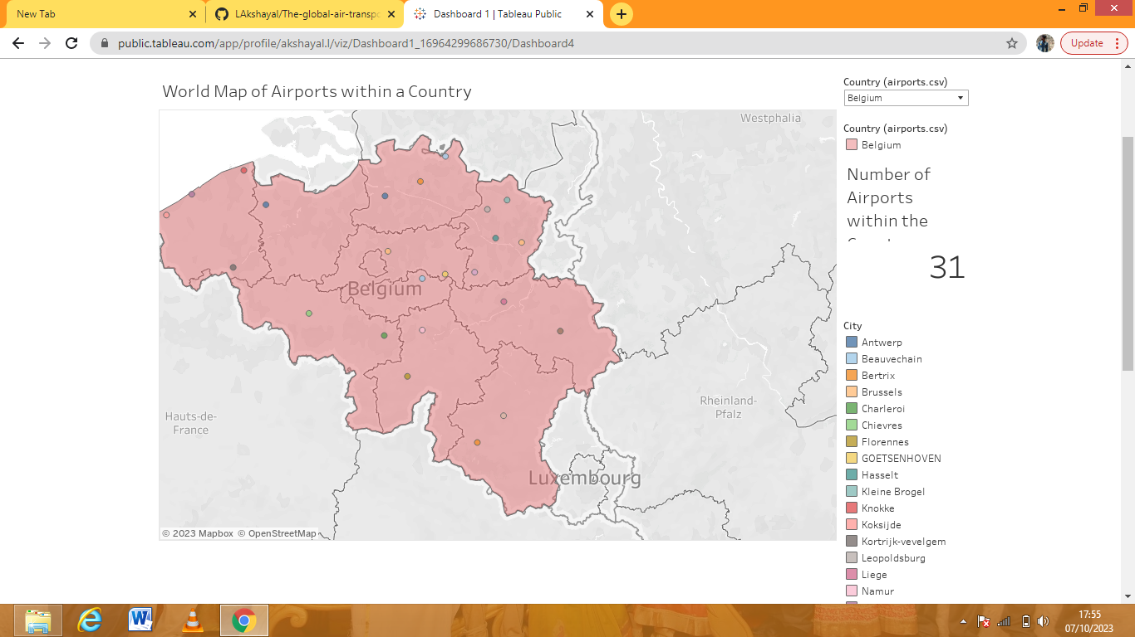

In the dashboard 1 we saw the location of the airports within a country in world map.

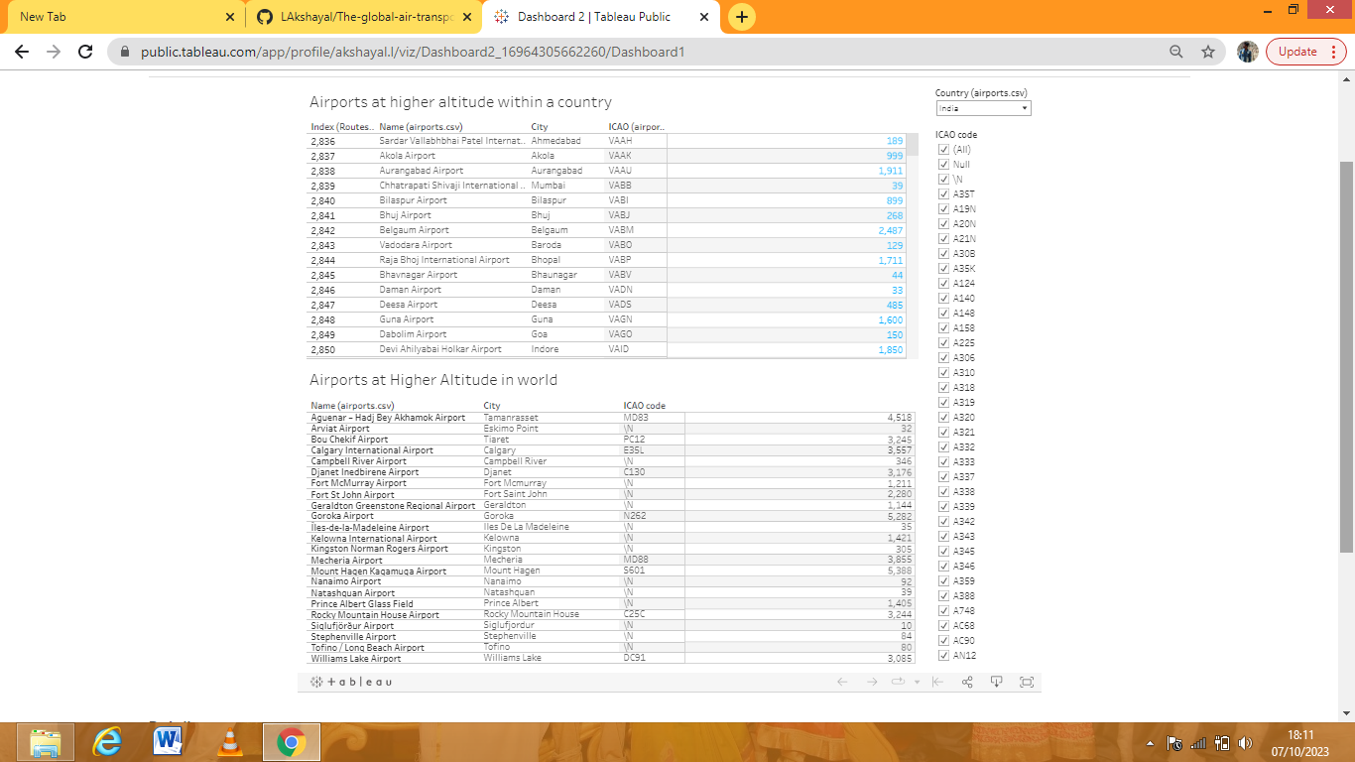

In the dashboard 2 we saw the airports at higher altitude in country and world.

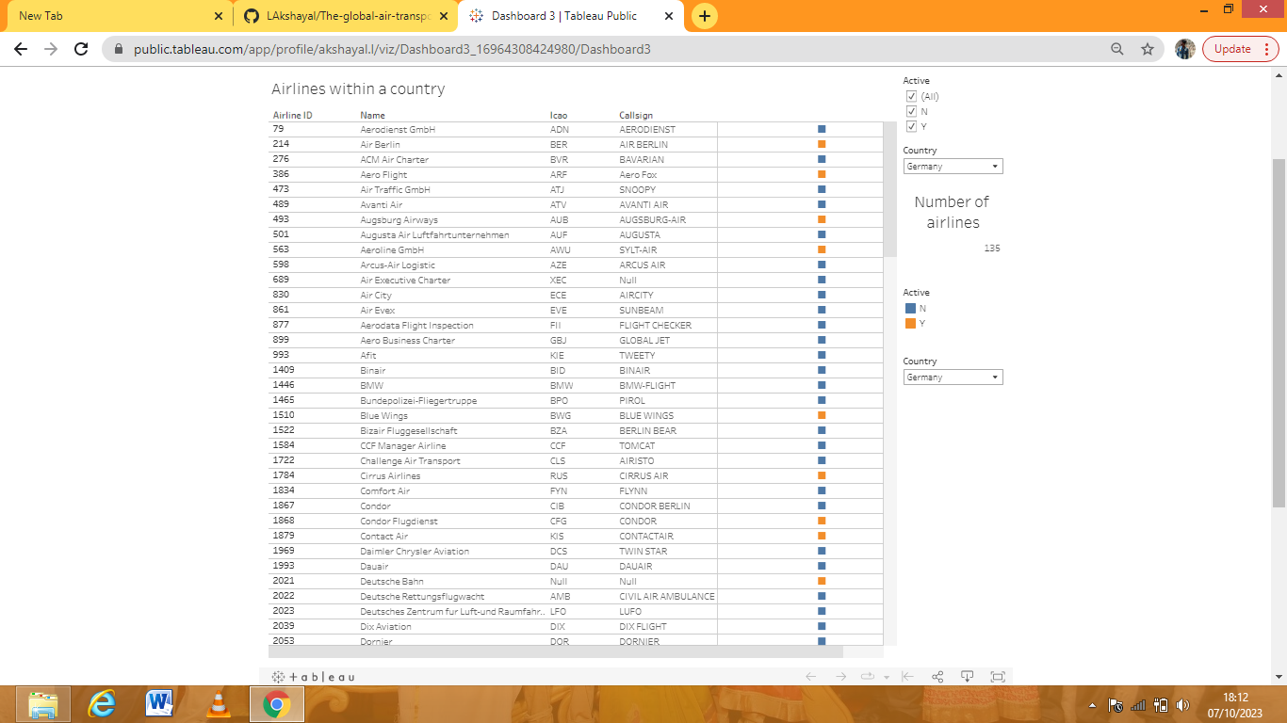

In the dashboard 3 we saw the airlines within a country.

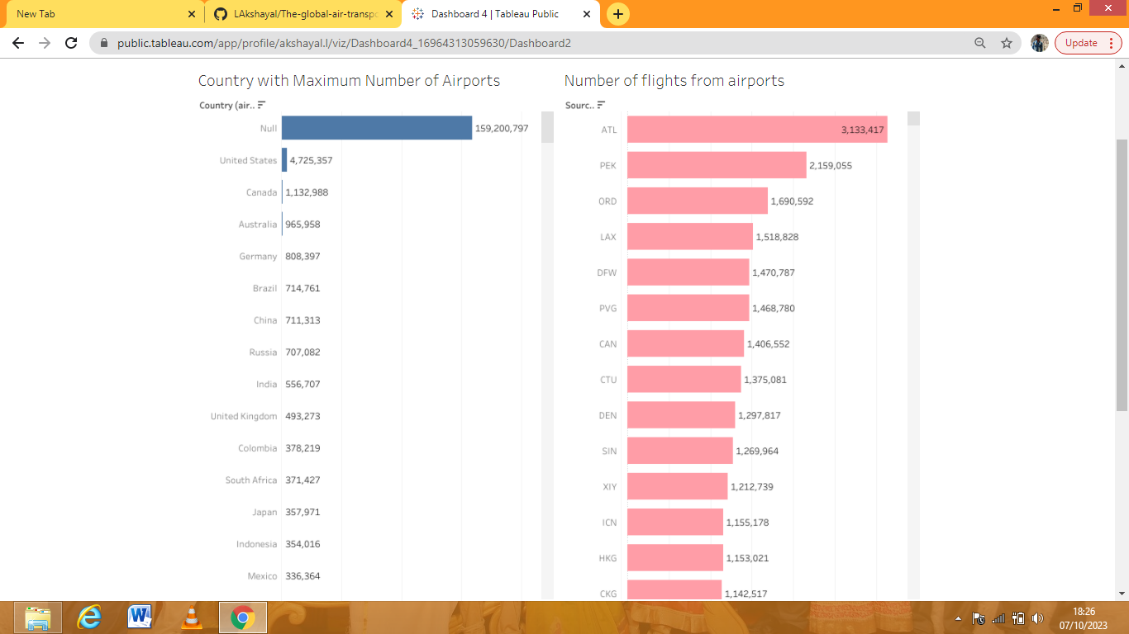

In the dashboard 4 we saw the country with maximum number of airports and number of flights from airports.

1. **STORY:**

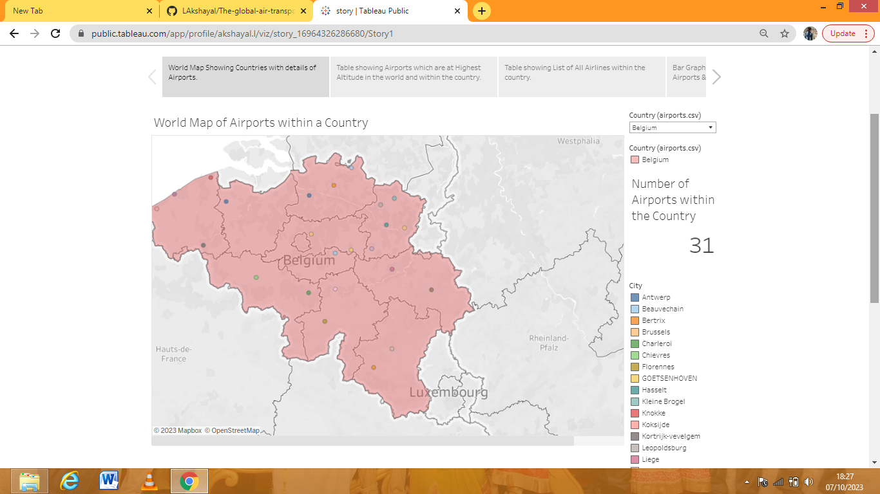

World map of airports within a country

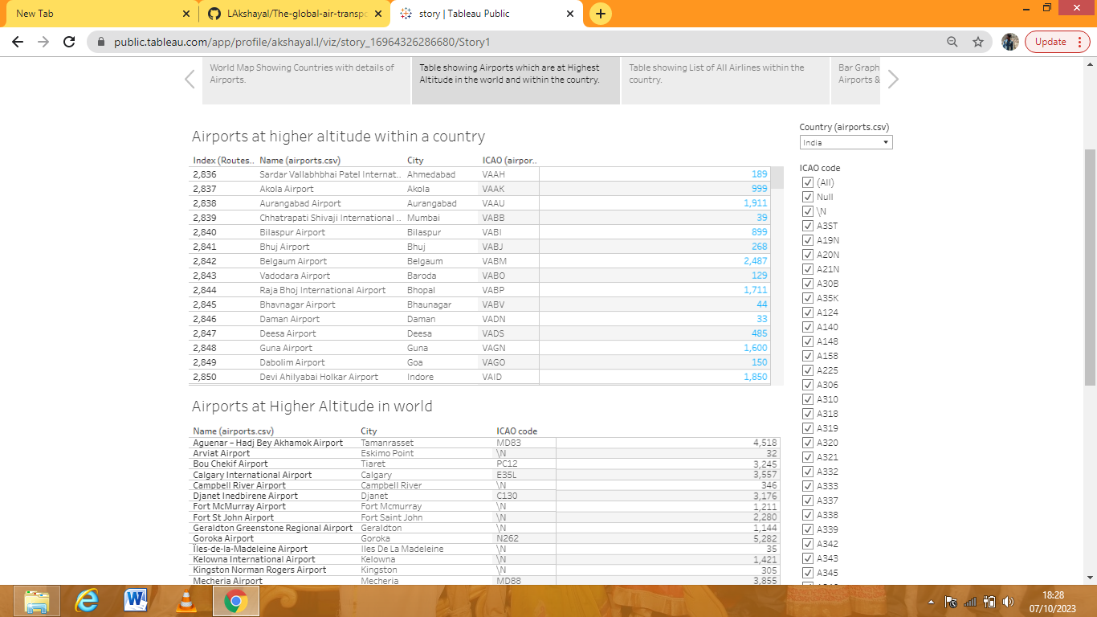

Airports at higher altitude within a country and world.

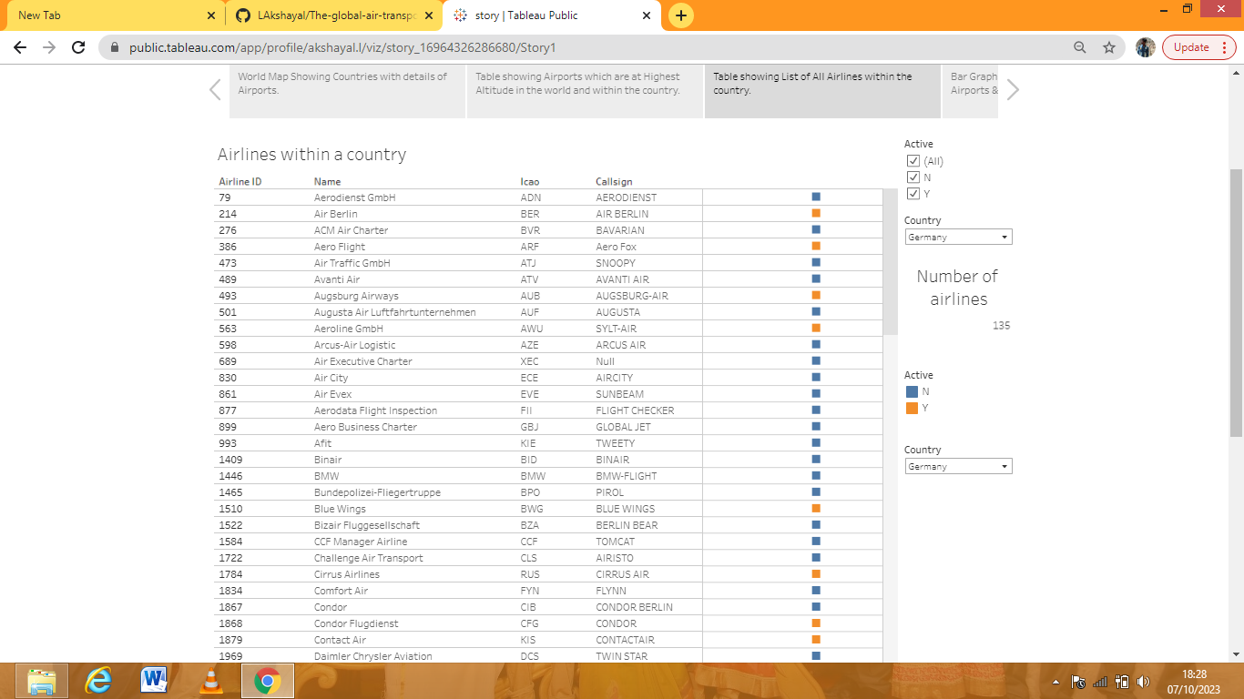

Airlines within a country

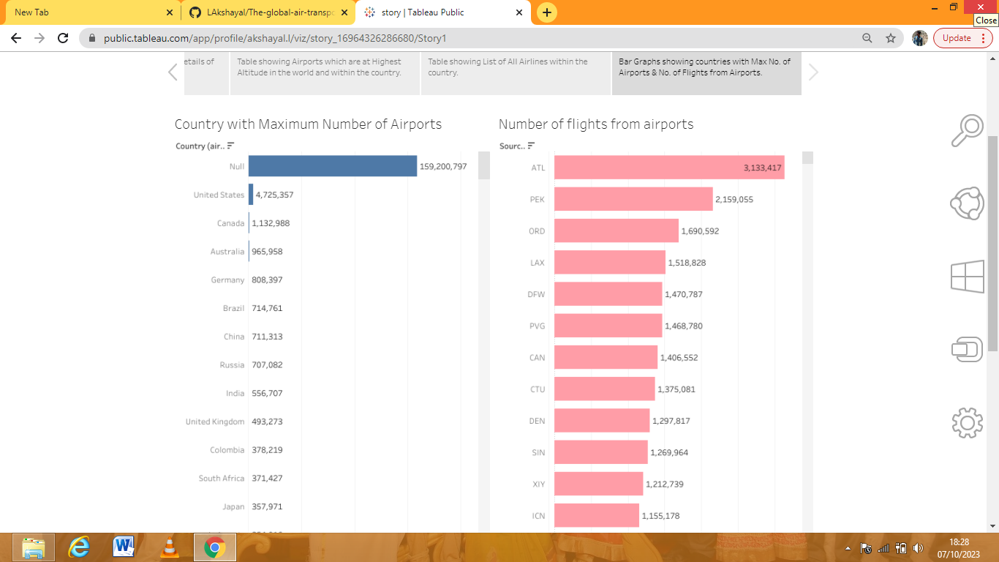

Country with maximum number of airports and number of flights from airports.

1. **AIR TRANSPORTATION NETWORK ADVANDAGES AND DISADVANDAGES**:

**ADVANDAGES**:

* High speed
* Comfortable and quick services
* No investment in construction of track
* Emergency services
* National defence
* Space exploration

**DISADVANTAGES:**

* Very costly
* Small carrying capacitiy
* Uncertain and unreliable
* Break down and accidents
* Large investments
* Unsuitable for bulky good